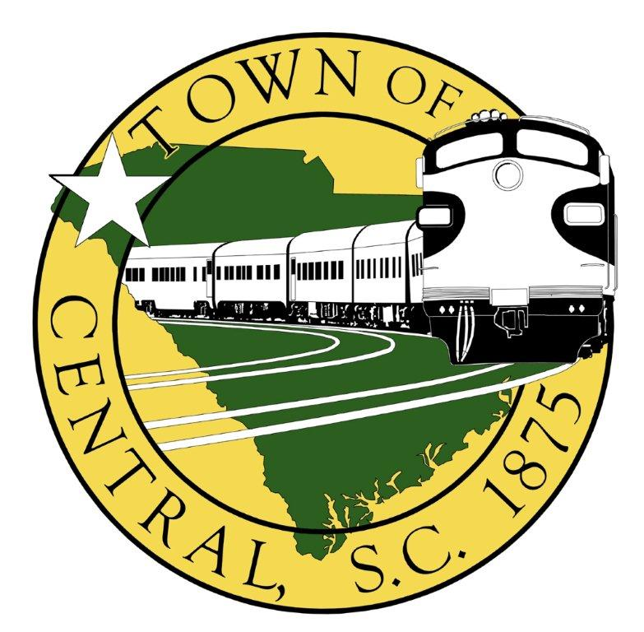

CENTRAL PLANNING COMMISSION MEETING
OCTOBER 18TH, 2022 6:30 PM
CENTRAL TOWN HALL
1067 WEST MAIN STREET, CENTRAL, SC 29630

AGENDA

- Call to Order

- Roll Call
Justin Rakey (Chair) David Vaughn (member) Lauren Queen (member)
Tripp Brooks (Vice Chair) Edith Williams (member) Paige Bowers (Council Advisor)
Erin Ash (Secretary) Daniel Bare (member) Jennifer Vissage (Zoning Admin)

- Approve Minutes from August 16th, 2022 and September 20th, 2000 meetings

- Old Business
  - Sign Ordinance updates
  - Comprehensive Plan updates

- New Business:
  - Amendment to Section 515 – University District
    - Addition of proposed section 515.6 – “Other Requirements”
  - Rezoning Request – Parcels #4076-17-00-9349 and #4076-17-00-7028 located near the intersection of Thomas Lane and SC Hwy 93 from University District to R6.

- Wrap-up items:
  - Next Meeting – Tuesday, November 15th, 2022

Adjourn

